Technical Documentation – FHT 8v Valve Controller
Some content is based on the information found here: http://www.mike-stirling.com/notes/fht8v-protocol/
Structure of Valve Controller System
HomeOS Application
HomeOS Driver
PSoc RadController
N Valves
USB Serial
FHT8V Protocol
868 MHz Wireless

Figure 1: Valve Control System structure
FHT8V Protocol
Bit encoding
Bits sent to the valve drives are represented as follows:
0: 400us transmitting, 400us silence (send_zero function)
1: 600us transmitting, 600us silence (send_one function)
Packet encoding
Every packet is sent with a preamble of twelve 0 bits followed by a 1. Each byte is followed by a parity bit which ensures even parity.
The bytes in a packet are as follows:
0 – RC1
1 – RC2
2 – Address
3 – Command
4 – Extension
5 – Checksum (sum of all bytes + 12)
A value of 0 for RC1, RC2 and Address is a broadcast message that will be read by all valve drives.
Command and extension bytes:
The upper 4 bits are flags. The only one used in this implementation is the 5th bit that denotes that an extension byte is present. This bit is set in all the commands sent.
The lower 4 bytes contain the command number. The command numbers used in the implementation are as follows:
Command name defined in implementation | Lower nibble | Total value sent (with upper nibble) | Extension byte
SEND_SET_VALVE_ADDR | 15 | 47 | Always 0
SEND_SET_VALVE_POS | 6 | 38 | Position value from 0-255
This Implementation of the Controller
The controller is sent instructions via serial communication. The string commands that it accepts are detailed in the table below. It stores the positions of each valve in an array which contains the room codes and address value as well as the position to send at wakeup time. Setting a position at any time will write to this array. The position will not be sent to the valves until wakeup.
Serial Command String | Function | When used by example HomeOS application
init | Controller sends back “HomeOSValveDevice\r\n” via serial. | Sent by the valve scout when in order to find valve controller devices.
getvalves | Controller sends back the number of valves that have been set up so far.
send | Controller sends an address packet (see above). The address will be of the form  RC1:n  RC2:1  ADDR:n  Where n is the number of valves set up so far (stored in the valve variable) +1  N will be the value that the user will use to addres the valve when setting positions. | When the user clicks “set up new valve”
done | Controller sends each of the valves their position (recorded in their array entry) in a position packet (see above). Each packet is sent in sequence. The controller starts its 2 minute wakeup cycle. | When the user clicks “done setting up valves”.  Note: In the example HomeOS application, the valve position for every valve in the array will always be 30% at this point as the user is disallowed from setting positions before completing setup. However, the valve controller itself is capable of writing positions to the valve array when setp commands are received before the done command is sent.
reset | Stops the 2 minute wakeup cycle of the controller and sets its ‘valves’ variable to 0.  This allows addresses to be sent from 1 again and a new cycle to start when the valves are set up again. | When the user selects “Reset all valves”
setp <valveNo> <pos> | Controller sets the position given for the valve number given in the valveNo argument. This is achieved by writing it into the position field for that valve in the array. This is now the value that will be sent to the valve at the next wakeup or when the done command is sent.  The valveNo value used for a valve is equal to its RC1 and ADDR values assigned at setup. | When the user selects “set certain valve”, after they have done setting up the valves.  Note: The user will enter a percentage value (0-100). The valve controller driver in HomeOS will convert that value into a 1-255 value that the controller and valve drives accept.
Setpa <pos> | Controller sets the position given in the argument for all valves. This is now the value that will be sent to each valve at the next wakeup or when the done command is sent. | When the user selects “set all valves”, after they have done setting up the valves.

Notes
Synchronisation:
The controller transmits and valves only turn on for about a second every ~2 minutes. For this reason, some information sites suggest that a synchronisation countdown must be sent to any valves being set up. This countdown consists of sending a packet with the number of half seconds until the valve should wake up. This should occur over 2 minutes. When the countdown is done, the controller should send a special End of Sync packet and start the cycle.
However, it has been found that this is unnecessary if set up is undertaken in the correct order. Once a valve drive has received an address packet, then it stays awake for at least ten minutes until it receives a set position packet. This is when it starts its 2 minute sleep-wakeup cycle.
Losing Sync
If the valves do not receive a valid packet for ~2 hours, the signal symbol will disappear and the valves will have to be set up again.
The countdown packets and end of sync could be used re-sync valves that have lost signal. This could be used in future versions of the radiator controller.
From http://www.mike-stirling.com/notes/fht8v-protocol/: To begin synchronisation the controller sends packets at one second intervals with command 12 (sync) and a down-counter in the extension byte. The counter starts at 241 and decreases by 2 each time. The last value to be transmitted is always 3.
The first command sent after the sync must be a command 0 packet, which completes the sync process. The time between the last command 12 and the command 0 can be found by:
t = 4 + 0.5 * (HC2 & 7) seconds
Packet Type | Lower nibble | Total value sent (with upper nibble) | Extension byte
Countdown | 12 | 44 | Number of half seconds until next wakeup
End of Sync | 0 | 32 | Empty

Addressing Scheme:
If a valve drive hears a packet with the same RC1 and RC2 byte that it was assigned at set up, then it will shut off its receiver until the next wakeup. To be able to set every valve’s position individually every two minutes, the implementation ensures that every RC1 is unique. It is set to the same value as the address of each valve. Both the RC1 and address value increases by one for every valve set up.
The wake up cycle is determined by the value of RC2. A valve with a RC2 value of x waits 115010 + (x&7)*500 milliseconds between wake-ups. In order to ensure that all valves wake up at the same time, the RC2 value for every valve is set to 1 in this implementation.
In the addressing scheme used in this controller implementation, the first valve to be sent an address receives 1 1 1, second receives 2 1 2, etc.
Maximum number of valves
The controller has been tested with and can guarantee correct control of up to 16 valves. The valves time their wakeup to the first set position packet. As the controller will send each position packet in sequence, each valve has an offset from the first valve's wakeup cycle (see figure 2). Therefore, in theory a much larger number of valves could be controlled by the same controller, as the controller will always send the position packets in the same sequence at wakeup time. Reversing the order that the position packets were sent after sending the first resulted in only the valves close to the middle of the set continuing to receive packets.
Set pos.
for v 1
Set pos.
for v 2
Set pos.
for v 3
Set pos.
for v 4
Set pos.
for v 2
Set pos.
for v 3
~62 ms
Set pos.
for v 1
Set pos.
for v 4
10 ms
118510 ms ms
Figure 2: Sending positions in cycle for 4 valves
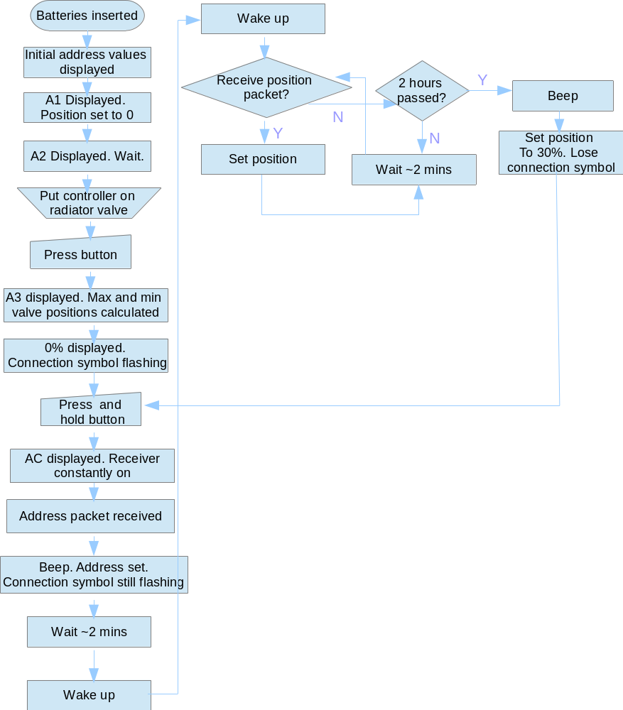
Figure 3: Flow chart of valve functionality

